Fighting Back: Olivia

Part I

By. CCNY Dispatch

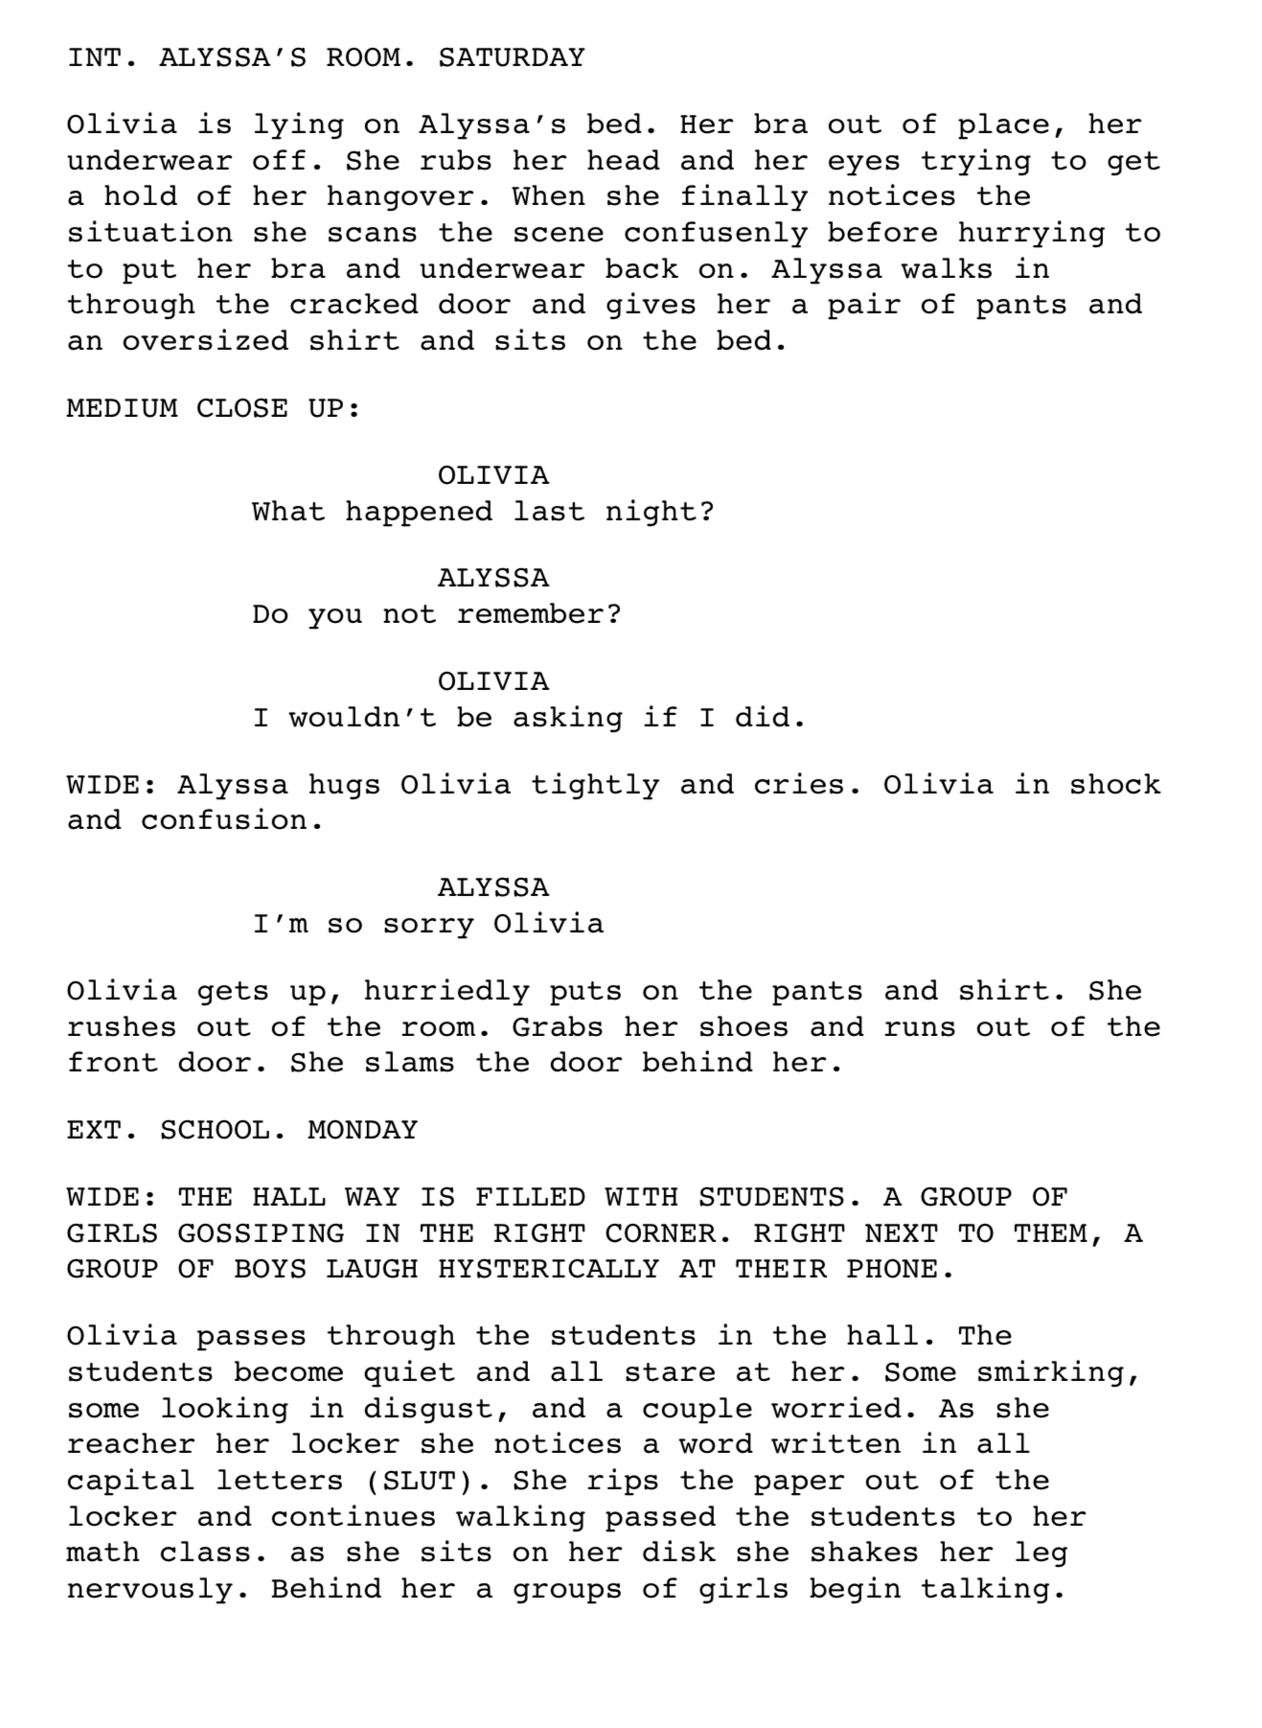
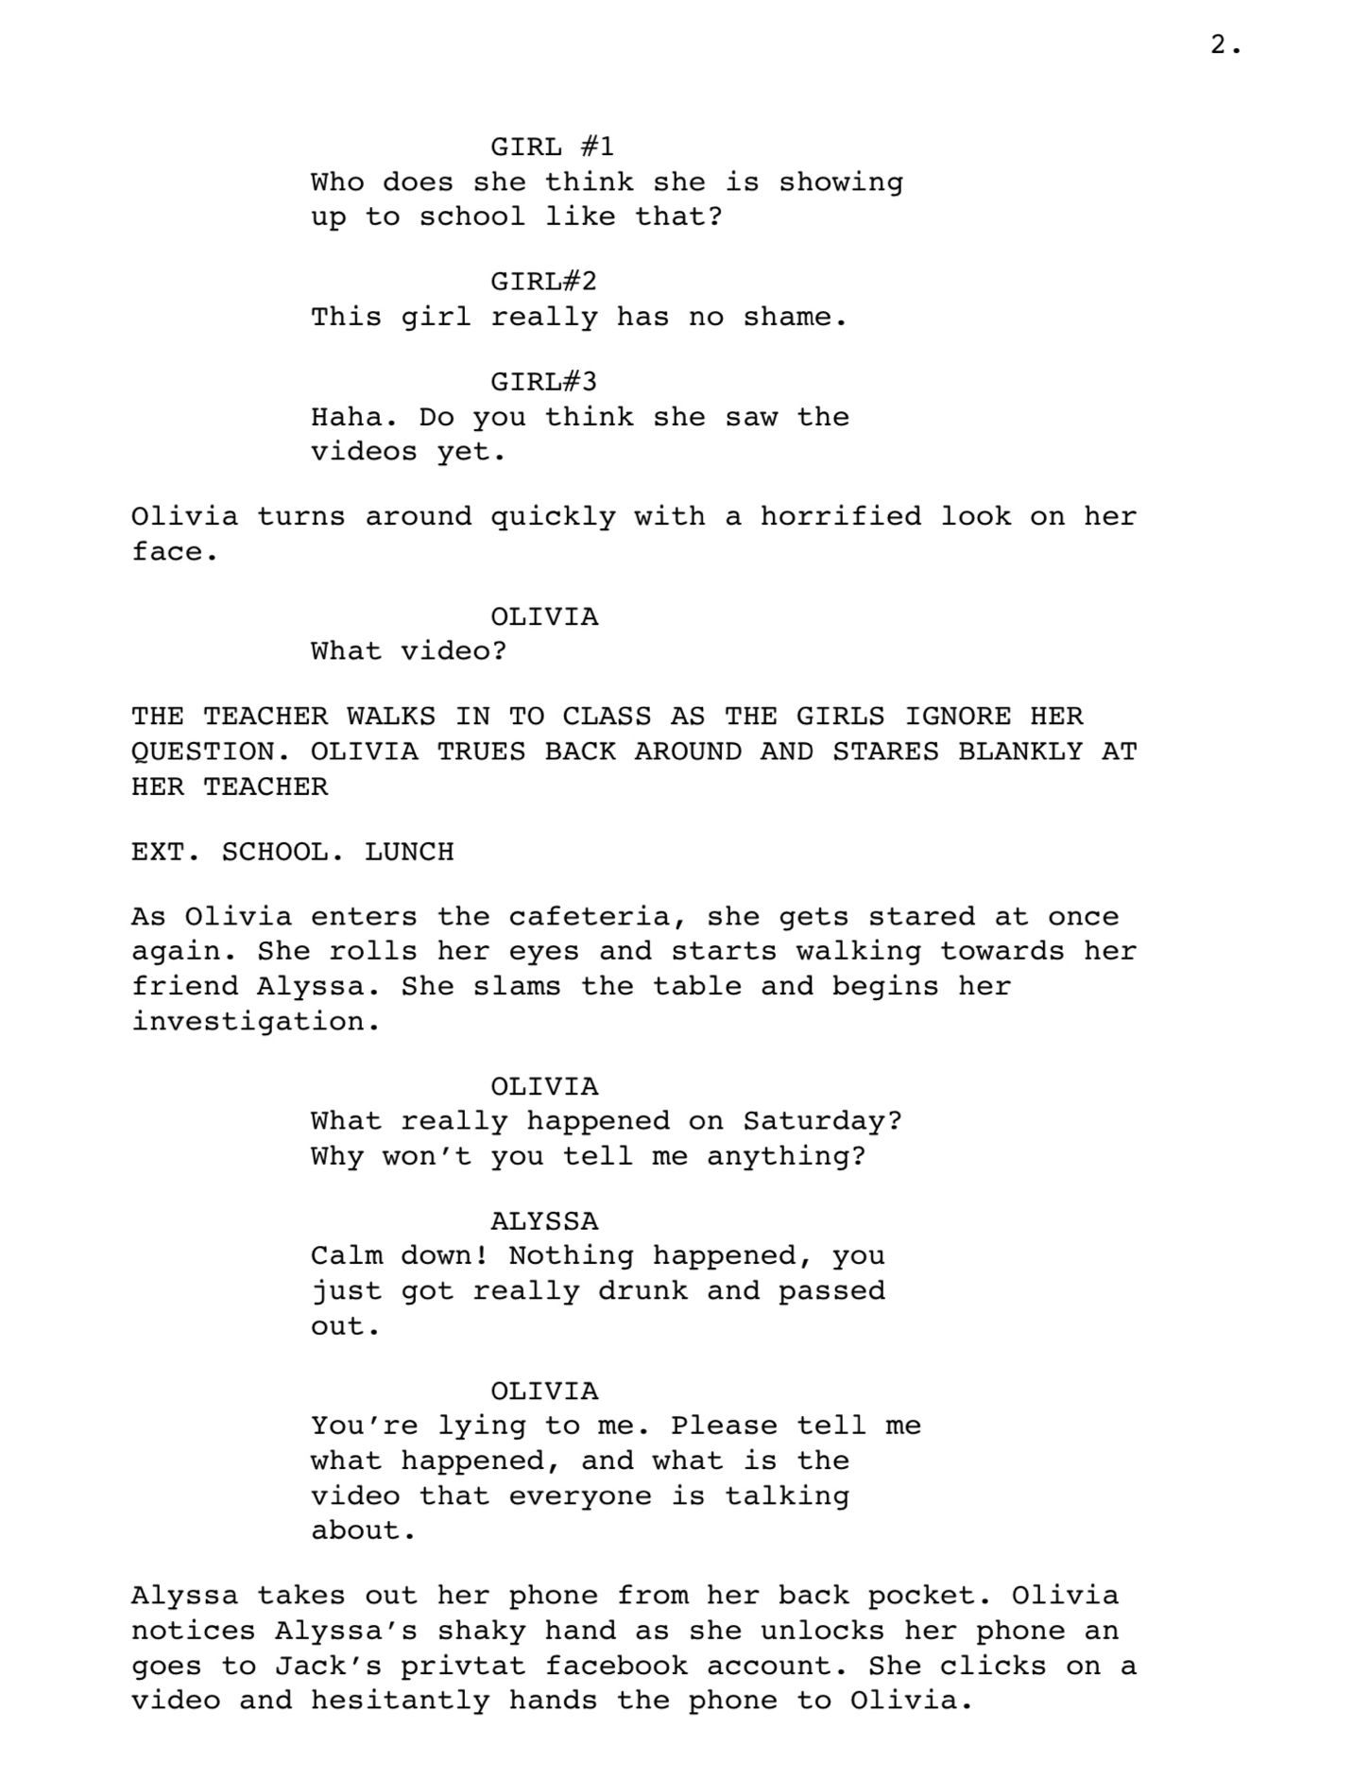
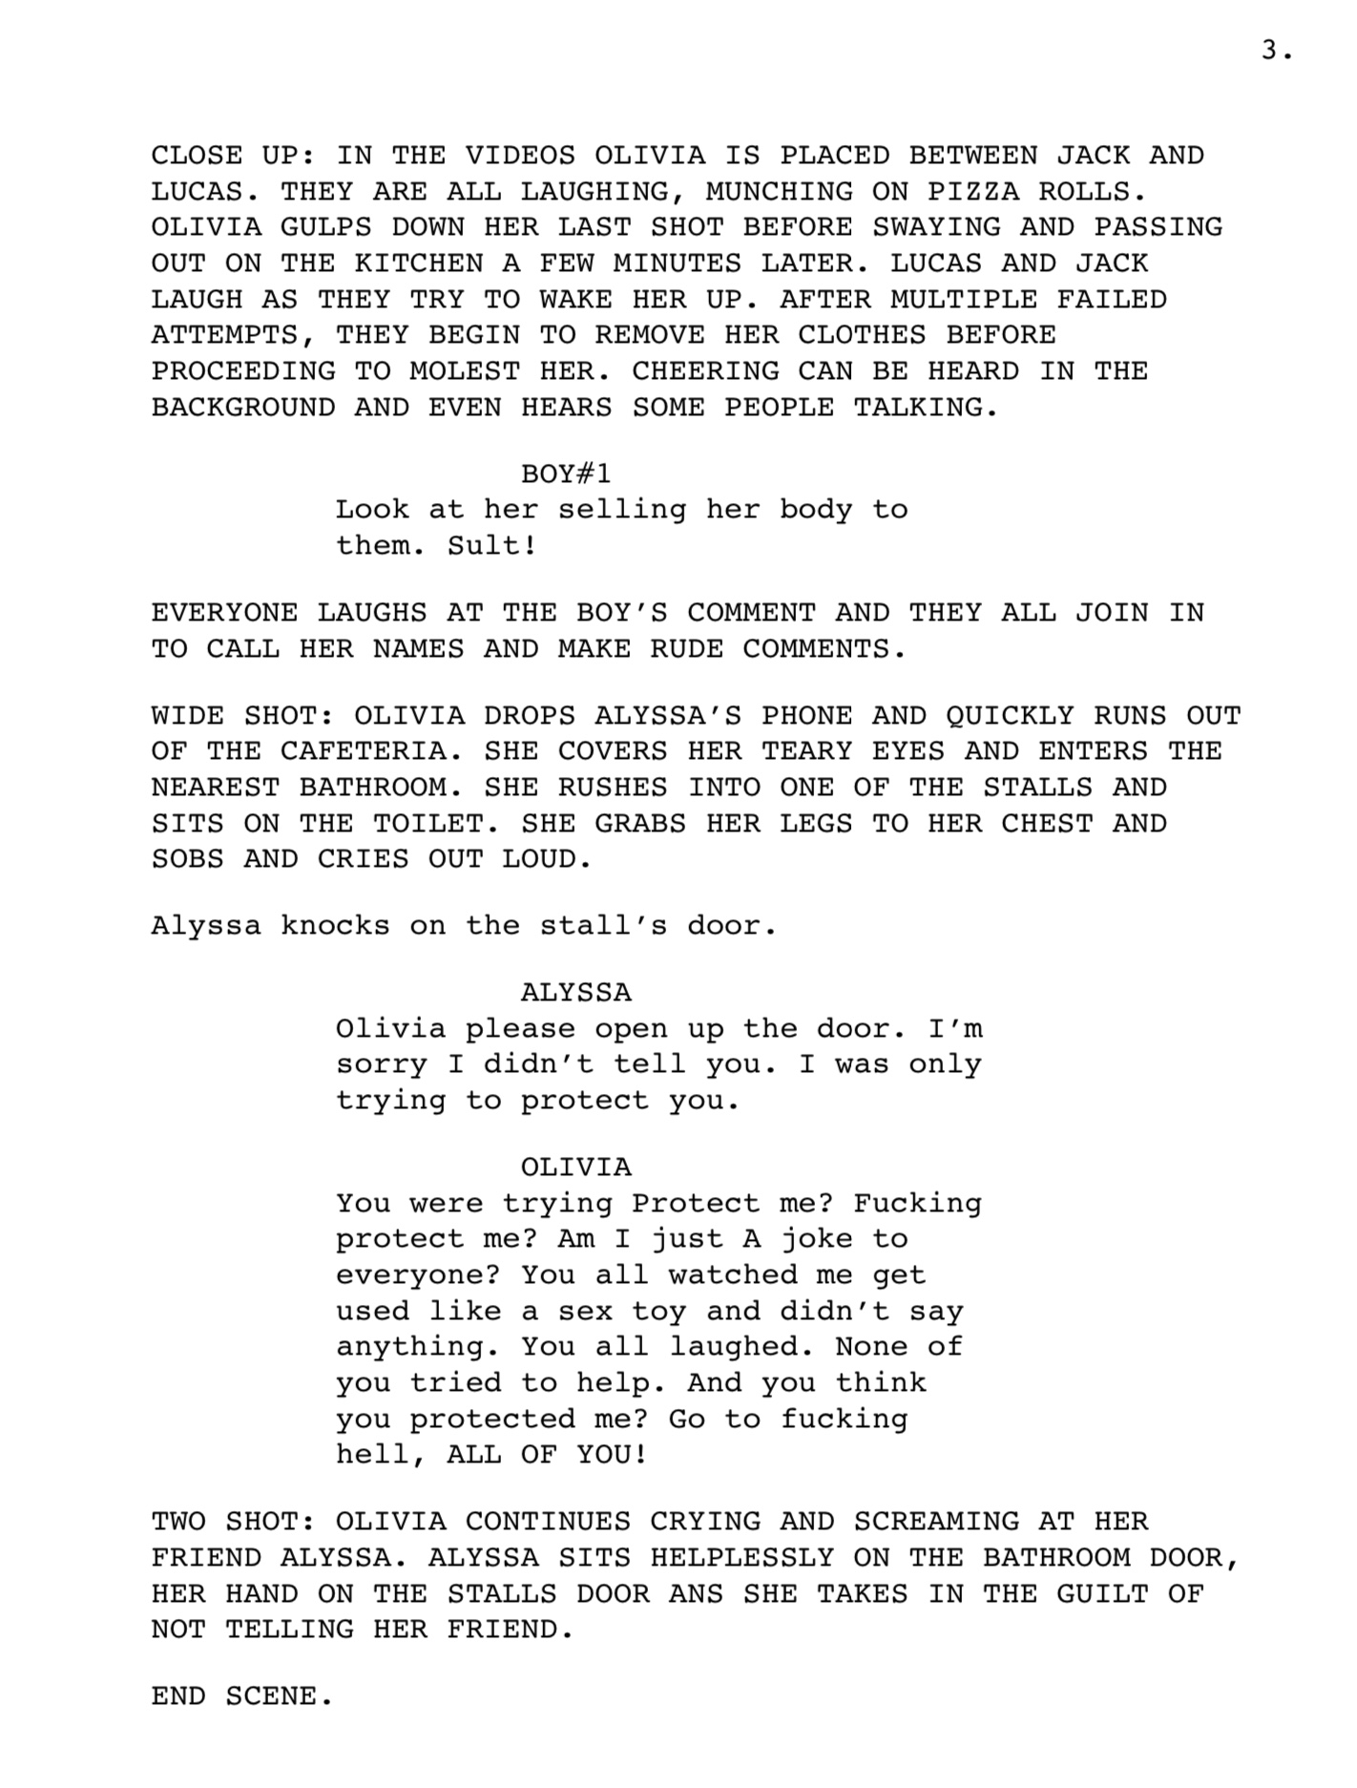
Rational for Script
The first component of the Composition in Two Genres is a short film script. This is part of a continuous series on YouTube called “Let’s Help Them Find Their Voice,” where each season focuses on a real sexual assault series that will be made into short films. The first series is Fighting Back: Olivia and the script is the first part of the story. It is based on a real story that happened to a teenage girl from Texas, Savannah Dietrich, who was sexually assaulted by two of her friends as she passes out at a party. The friends proceed to make fun of the situation by recording parts of the instances and going to social media where they continuously harass her. Her story, however, doesn’t end there as she fights back and gets the two guys in jail. In the script, the story is a little exaggerated, censored in some areas, and the names of the characters are changed out of respect to Savannah.
The target audience of the short films is teenage girls, which experience the most cases of sexual assaults. In order to fully grasp the attention of these girls, the videos are posted on YouTube, one of the most utilized social media platforms, and they can watch them at no cost. This will also act as a platform where they can share their own stories and experiences to bring more awareness to the issue. If there are others, however, that are not teenage girls and want to share their own stories as well, they are more than welcome to.
As previously mentioned, this will be a continuous, series meaning that it won’t reach an end, because it will be a coping method for the victims. The purpose is to get the films to spread across the platform and get parents to also react to them so they can educate and warn their kids about this occurrence. Lastly, the videos call for government officials to recognize sexual as a major crime and develop serious penalties.
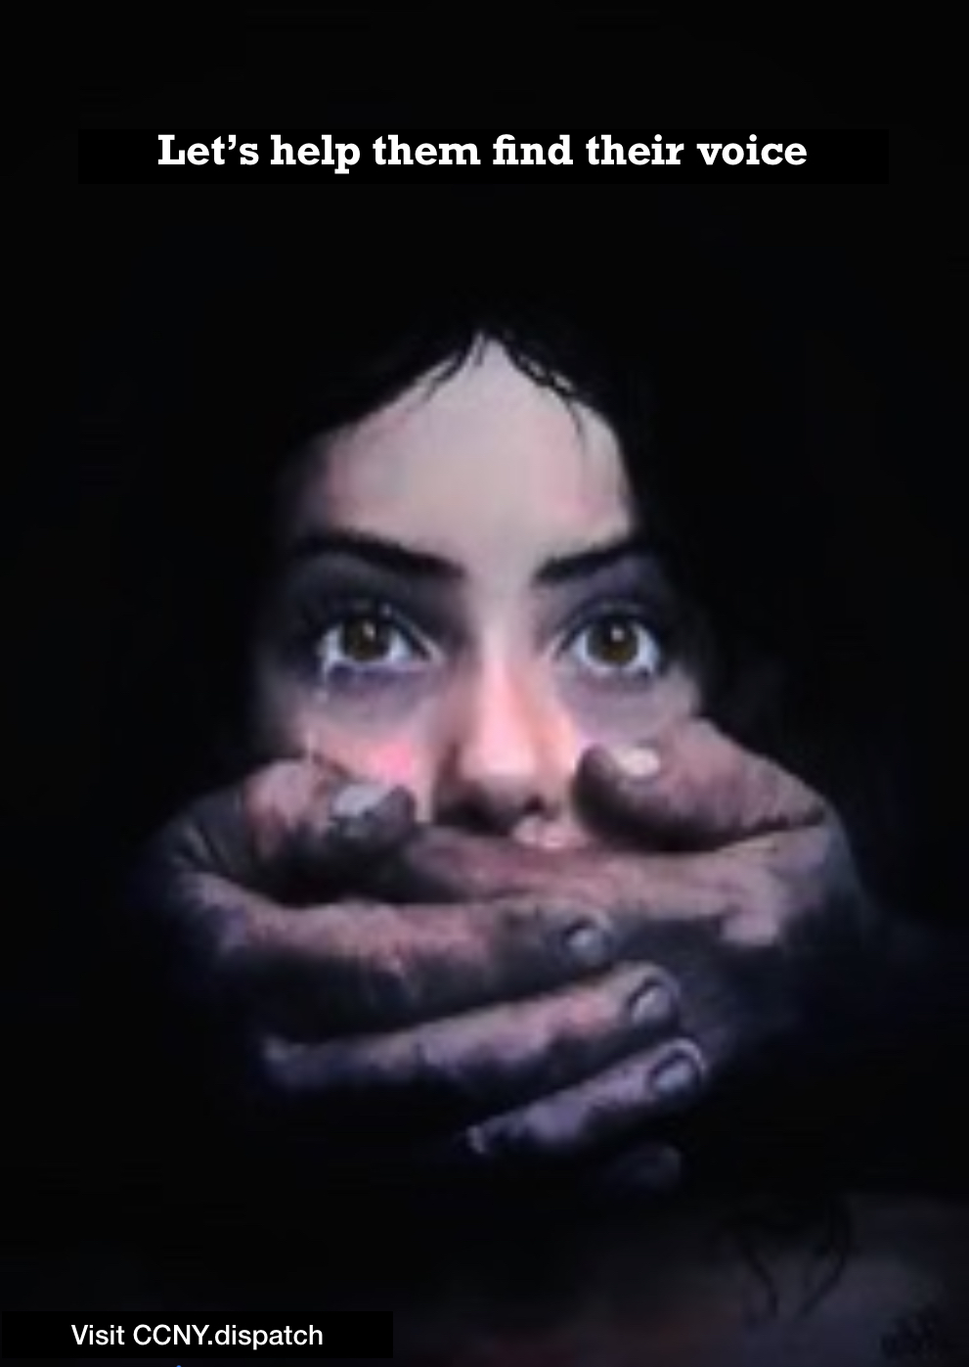
Rational for Poster
The second component of the Composition of the two genres is the poster above. As a side note, this is not a drawing that I created but was a picture that I found online and edited to fit my liking. It was not mentioned as to who drew the piece, but a signature can be visible in the down right corner. Moreover, this poster represents a campaign called “Let’s Help Them Find Their Voice.” The campaign consists of a group of CCNY students that create flyers and go to events to help spread awareness about the club and the issue. This is the second part of a bigger project; the campaign and the YouTube videos.
The target audience of the poster are people that we couldn’t reach in our YouTube videos; from young adults to parents, to the elderly. The idea is to get as many people, from all different age groups to become more aware of the issue and support the call for government actions. The YouTube videos are successful in the younger audience while older people are more likely to go to events and conferences about such issues.
The purpose of the poster to call for everyone to talk about the issue of unreported sexual assaults, These assaults occur the most amongst high school students, the stage where they are still figuring out themselves. Thus, such experiences are very scarring and triggering. However, it’s still not fully recognized as a major issue and the city government in NY doesn’t even recognize it as a crime. This poster and the campaign are set to get victims to speak, parents to call for action, and for the government to actually listen and take legal actions.

Reflection
For an indecisive person, the Composition in Two Genre Essay is the most difficult piece for this class. Although I had a set audience, purpose, and stance for the essay, I constantly struggled with finding the most appropriate genre to present my ideas. What started with a movie and flyer, ended with a script for YouTube videos and a campaign poster.
From the very beginning, I had a specific purpose for the project, and I knew exactly my target audience. I am taking the stance of a person that is spreading awareness about the issue of unreported sexual assaults, and an activist that calls for government recognition and action about the stance. Through this project, the main goal is to get people to be more careful around everyone for any person can become a perpetrator, and hopefully to get victims to feel more comfortable to report their experiences knowing that the law is protecting them throughout the process.
However, and as mentioned previously, I couldn’t choose the right genre to help me get my points across. At first, I wanted to create an educational YouTube video, that acts about a documentary about sexual assaults, along with an informational flyer. However, I realized that not everyone will watch a documentary and that the flyer has too many words, and so people wouldn’t actually go ahead and read them. Then, I thought of changing the documentary into a video that talks about a specific case of sexual assaults and cybercrime, which didn’t work out due to my horrible editing skills. Finally, I chose to do a script for a part of the short films that will be posted on YouTube. The younger audience is more likely to watch a film than a documentary so this will help get the point across. In addition, instead of a flyer, I made a poster with as few words as possible. The photo in itself is attention grappling and would get a person to stop and think about it. The thought process is that some pictures speak louder than words.

